Project - Task 5

CSE332s: Design and Analysis of Algorithms

# 1. Problem Description

“There are n coins placed in a row. The goal is to form n/2 pairs of them by a sequence of moves. On the first move a single coin has to jump over one coin adjacent to it, on the second move a single coin has to jump over two adjacent coins, on the third move a single coin has to jump over three adjacent coins, and so on, until after n/2 moves n/2 coin pairs are formed. (On each move, a coin can jump right or left but it has to land on a single coin. Jumping over a coin pair counts as jumping over two coins. Any empty space between adjacent coins is ignored.) Determine all the values of n which the problem has a solution and design an algorithm that solves it in the minimum number of moves for those n’s. Design greedy algorithm to find minimum number of moves.”

# 2. Detailed Assumptions

We assumed that in both solutions either the greedy or the brute force, the algorithm will start from the very first coin in the left most of the row and work its way to the right direction. As it’s arbitrary to start from any coin and work its way in any direction and there’s no constraints or cases that will go against this assumption, so there’s no problem to assume that we will start from that coin and in that direction.

# 3. Detailed Solution

## 3.1. Key-Observation

If we try by hand to solve this problem, we will find that some values of n work fine and other doesn’t, some of the values that works are 4, 12 and 28. We need to observe the pattern or the mathematical formula, and after that use it to deduce the next values, then finally test those values to see if the pattern or the mathematical formula was right or wrong. After looking for some formulas and pattern, there’s only one simple pattern or formula that satisfies the problem constraints, and it is as follows:

If we assume that the value of n is equal to the sum of two big piles of mathematically calculated number of fours, then you could put the 4, 12 and 28 as follows: 4 = (0) + (4), 12 = (4) + (4+4), 28 = (4+4+4) + (4+4+4+4) then you we can deduce a mathematical formula based on that, and it is as follows:

***n = ((2^(i)-1) + (2^ (i )) ) * 4 = (2^(i+3)) - 4 where i is a non-negative integer.***

Then for i=0 -> n = 4, for i=1 -> n=12, for i=2 -> n=28, for i=3 -> n=60, etc.…

If you try n=60, it will work. So, the deduced formula is right, hence that was one of the requirements, what are the values of n that satisfies the problem constraints? **(2^(i+3)) – 4 where i is a non-negative integer.**

## 3.2. Greedy Technique

### 3.2.1. Key Idea

Simply start from the left most of the row, set the number of moves to zero and start moving the first coin according to the constraints of the problem to form a pair in the left direction, then next ***choose the nearest coin to the empty space that it was left behind (greedy step)***, increment the number of moves then repeat the steps again until you form n/2 coin pairs in just ***n/2 moves which is logically the minimum amount of moves required to form n/2 coin pairs.***

### 3.2.2. Pseudocode

#### 3.2.2.1. High-Level

1. Set the current move to 0.
2. Start from the leftmost coin.
3. Iterate through the row until you reach the coin before last.
   1. For each single coin you find while iterating, start to the column to the left of it.
      1. Increase the current move by one.
      2. Set the count of jumped over coins for this specific coin to 0.
      3. If the current jumped over coins count equals the current move, then put the single coin on the current column to form a pair, then break out of this loop to go to the next nearest single coin to the previous one that we selected.
      4. Else if the current jumped over coins count doesn’t equal the current move, then increase the jumped over coins by the number of coins in the current column and go to the next left column.

#### 3.2.2.1. In Details

numberOfMoves <- 0

For i = 0 to n-1 {

// skip empty spaces or coin pairs until you find the ***nearest*** coin ***(greedy step)***

if(rowOfCoins[i] != 1)

continue

numberOfMoves <- numberOfMoves + 1

jumpedOverCoins <- 0

// making a coin move to form a pair of coins

For j=i+1 to n-1 {

if (jumpedOverCoins == numberOfMoves) {

rowOfCoins[i] <- 0;

rowOfCoins[j] <- rowOfCoins[j] + 1

break

}

// counting the number of jumped over coins

jumpedOverCoins <- jumpedOverCoins + rowOfCoins[j];

}

}

## 3.3. Brute-Force Technique

### 3.3.1. Key Idea

Again simply start from the left most of the row, set the number of moves and start moving the first coin according to the constraints of the problem to form a pair in the right direction of the row, and if no place was found satisfying the constraints to form a coin pair then search in the left direction for a place, if also no place was found satisfying the constraints then we go back one step to the previous pair that was formed, unform it then try to find another different place for that previous singe coin to form a pair then go to the next single coin that we couldn’t find a place for it to form a pair in the first place, then we try to find a place for it, ***eventually we will repeat the steps and make our way brute forcing it with those steps*** until we make n/2 coin pairs in just ***n/2 moves which is logically the minimum amount of moves required to form n/2 coin pairs.***

### 3.3.2. Pseudocode

#### 3.3.2.1. High-Level

1. Start by calling the function to run at the left most position and operate in the right direction of the row.
2. Check if the position passed is valid, if not then return false.
3. Set the number of moves to 1 and make a flag that determines if we are done or not and set it to false.
4. Set the count of jumped over coins to 0.
5. Start iterating from the column to the to the left or right of the passed position as it was specified in the function call, and do the following in each iteration:
   1. If the current jumped over coins count equals the current move, then put the single coin at the specified position on the current column to form a coin pair, increase the current move number by one, set the flag to true, then finally break out of this loop to go to the next nearest single coin to the previous one that we selected.
   2. Else if the current jumped over coins are greater than the current move then breaks out of the loop.
   3. Else if the current jumped over coins count are less than the current move, then increase the jumped over coins by the number of coins in the current column and go to the next left or right column as the direction was specified at the beginning of the loop in the function call.
6. Check if there’s still any single coins left and if so, set the flag to false.
7. If the flag is true, then return true.
8. Determine the next position of the next single coin that will be moved to form a coin pair.
9. Call the function again with the new position calculated in the right direction (go to step 2) and set the returned value out of the function to the flag.
10. If the flag is true, then return true.
11. Call the function again with the new position calculated in the left direction (go to step 2) and set the returned value out of the function to the flag.
12. Return the flag value.

#### 3.3.2.1. In Details

algorithmUsingBruteForce (position, currentMoveNumber, direction) {

if ((position < 0) || (position > n))

return false

numberOfMoves 🡨 currentMoveNumber

jumpedOverCoins 🡨 0

doneFlag 🡨 false

// check in the right direction the possibility to form a pair

if (direction == "right")) {

for i 🡨 position+1 to n-1 {

// move the coin to the column if the condition is satisfied

// or break if exceeded

If (jumpedOverCoins >= numberOfMoves) {

if (jumpedOverCoins == numberOfMoves) {

rowOfCoins[position] 🡨 0

rowOfCoins[i] 🡨 rowOfCoins[i] + 1

currentMoveNumber 🡨 currentMoveNumber + 1

doneFlag 🡨 true

}

break

}

// or jump over the column and count the jumped over coins

else if (jumpedOverCoins < numberOfMoves)

jumpedOverCoins 🡨 jumpedOverCoins + rowOfCoins[i]

}

}

// check in the left direction the possibility to form a pair

else if (direction == "left")) {

for i 🡨 position-1 to 0 {

// move the coin to the column if the condition is satisfied

// or break if exceeded

If (jumpedOverCoins >= numberOfMoves) {

if (jumpedOverCoins == numberOfMoves) {

rowOfCoins[position] 🡨 0

rowOfCoins[i] 🡨 rowOfCoins[i] + 1

currentMoveNumber 🡨 currentMoveNumber + 1

doneFlag 🡨 true

}

break

}

// or jump over the column and count the jumped over coins

else if (jumpedOverCoins < numberOfMoves)

jumpedOverCoins 🡨 jumpedOverCoins + rowOfCoins[i]

}

}

// check if there're still single coins

For i in rowOfCoins {

if (i == 1) {

doneFlag 🡨 false

break

}

}

// check if all are the coins are pairs

// if so, then we are done

if (doneFlag == true)

return true

// next single coin to be moved to form a pair

int nextPosition 🡨 position;

for i 🡨position+1 to n-1{

if (rowOfCoins[i] == 1){

nextPosition 🡨 i

break

}

}

doneFlag 🡨 algorithmUsingBruteForce (nextPosition, currentMoveNumber, "right")

// still, there're single coins?

If (doneFlag == true)

return true

doneFlag 🡨 algorithmUsingBruteForce (nextPosition, currentMoveNumber, "left")

return doneFlag

}

# 4. Complexity Analysis

## 4.1. Greedy Technique Complexity Analysis

In general, you loop over n in the left direction skipping every empty space and every coin pair that was formed, until you find a single coin, then you start to iterate in the same left direction until you find the right spot to put that single coin so you form a coin pair, then repeat.

For the first coin, you will jump over one coin, for the second you will jump over two coins, etc.…

As an approximation we could say that the whole time is upper bounded by:

***[1 + 2 + 3 + 4 + … + n/2] + n/2 where each number represents a coin that we iterated that number of times to find the right spot for it, except the last (n/2) it represents the skipped empty spaces and coin pairs that we looped through, but we didn’t select any of them.***

***So, [1 + 2 + 3 + 4 + … + n/2] + n/2 = ((n/2) * (n/2 + 1))/2 + (n/2) = ((n^2) / 8) + (3n/4) which is O(n^2) in all cases.***

## 4.2. Brute Force Technique Complexity Analysis

It is expected that the brute force technique will have a very high running time, higher than the greedy technique by a lot as it goes through a lot of paths most of them are wrong until it reaches the right path that leads to the solution, but the greedy chooses the greediest path from the start which is likely to be the solution or an approximate to it.

But in our case, and due to the assumption that we start in both algorithms from the left most coin and work our way in the right direction, the brute force technique will reach the right path from the first try as if it was the greedy technique, and then it will stop.

***So, the brute force technique will be upper bounded by approximately the same running time as the greedy technique which is O(n^2) and that is in all cases.***

## 4.3. Comparison Between the two techniques

As the two techniques has two different methods of finding the solution. But like discussed above, the two techniques will result in two different algorithms each will solve the problem and find the solution in approximately similar running time in all cases due to the problem nature and the assumption and implementations that were made.

# 5. Code in Java

## 5.1. Algorithm Using Greedy Technique

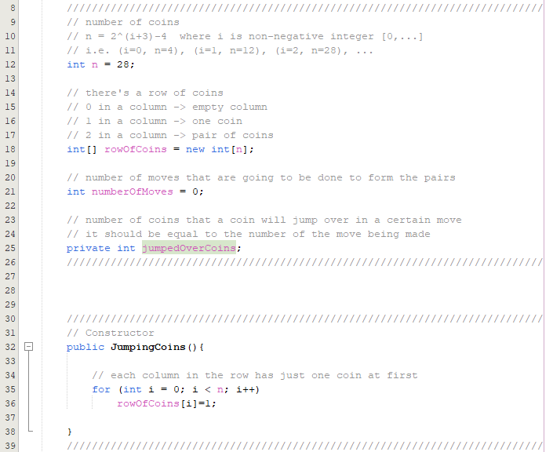

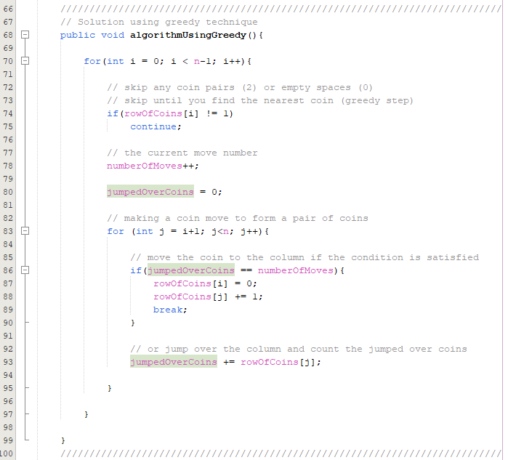

## 5.2 Algorithm Using Brute-Force Technique



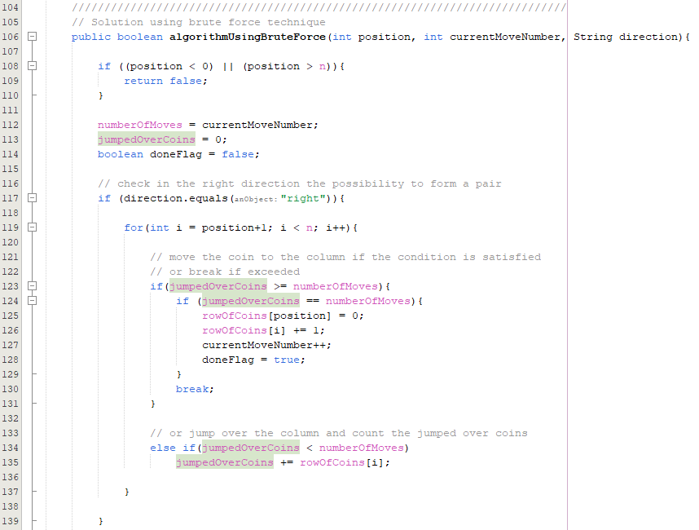

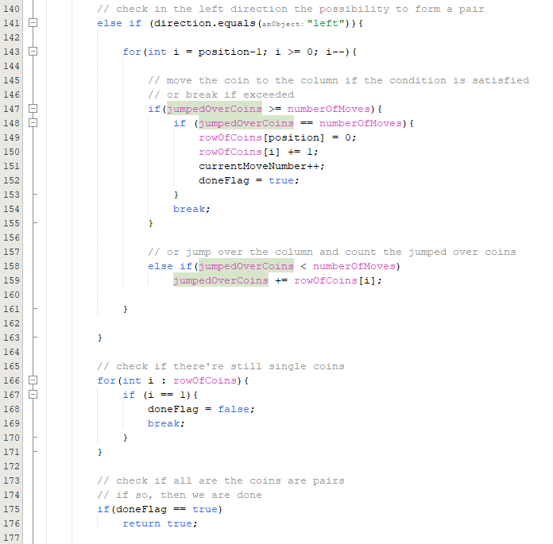

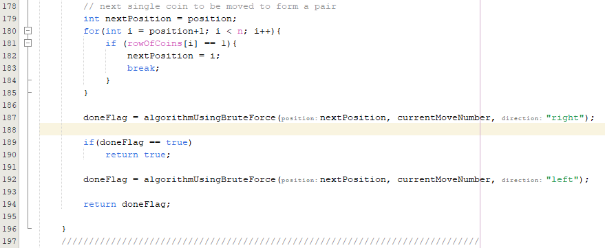

# 6. Output samples

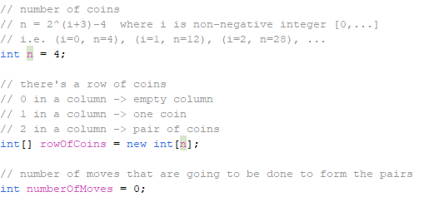

## Where n = 4

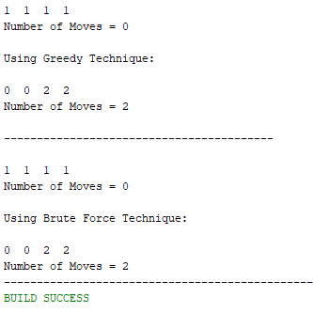

## Where n = 12

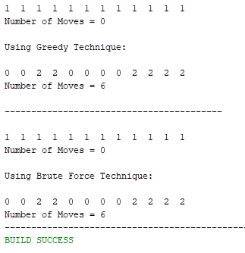

## Where n = 28

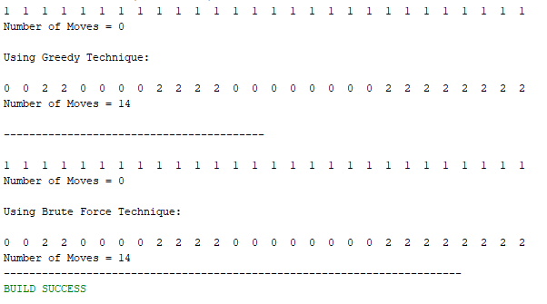

## Where n = 60

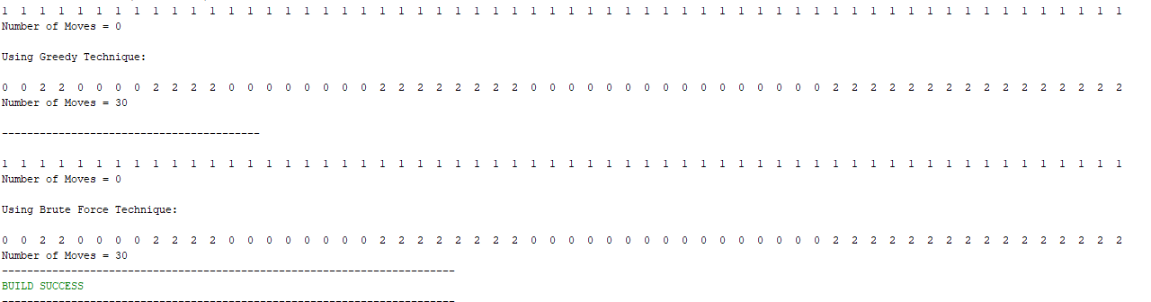

## Where n = 124

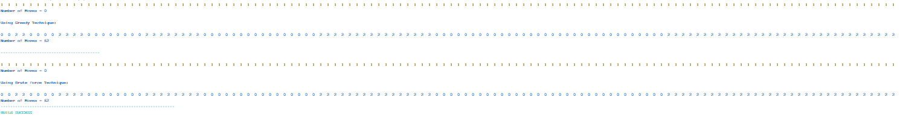

# 7. Conclusion

The values of n that satisfies the problem constraints are equal to **(2^(i+3)) – 4, where i is a non-negative integer** and two algorithms were designed one using the greedy technique and the other one using the brute-force technique to solve the problem.

There might be in some cases, two different techniques that could produce two different algorithms each one of them has its own way of finding the solution to the problem but due to the problem nature, implementation, assumptions and so on, they could end up with the same time complexity, like in our case in the discussed problem in task 5.

In our case we saw the problem solved by two different techniques the first one is the main one that was required which is the greedy technique which produced a solution that was upper-bounded by ***O(n^2)*** in all cases, and the second technique was the brute-force technique which could have led to a much higher running time but as we said due to the assumptions, implementation and the problem nature that helped in our case, the algorithm based on the brute-force technique produced a solution that was upper-bounded by the same running time as the algorithm based on the greedy technique which is ***O(n^2).***